Erwin Cheng
A04_ Fraud Detection Case Study
ITAI 2372 AI Applications
Anna Rachapudi

AI in Fraud Detection Case Study: Danske Bank

Introduction


Danske Bank, headquartered in Copenhagen, Denmark, is one of the largest financial institutions in Northern Europe, serving over 3 million customers. Like many major banks, Danske Bank faces ongoing threats from financial fraud, including credit card fraud, money laundering, and digital transaction fraud.
The bank has been around for over 140 years, but their old way of catching fraudsters was stuck in the past. They were using "rule-based" systems—basically a long list of "if this, then that" instructions written by humans.
The problem? Fraudsters are smart and they move fast. The old system was flagging thousands of innocent customers (false positives) while letting the real criminals slip through the cracks. They needed something that could learn and adapt on the fly, which is where AI came in.
Technology Overview
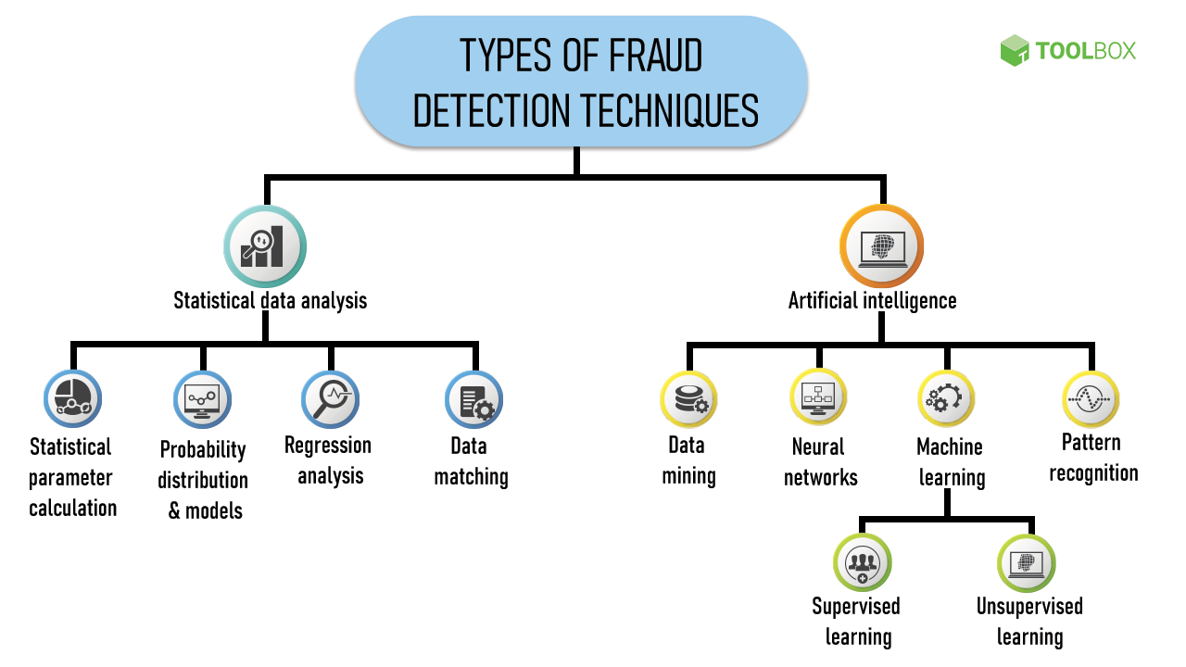
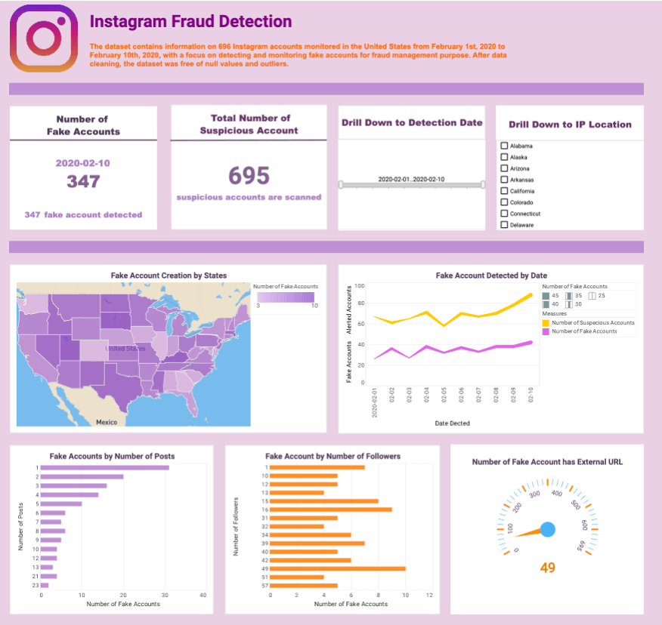
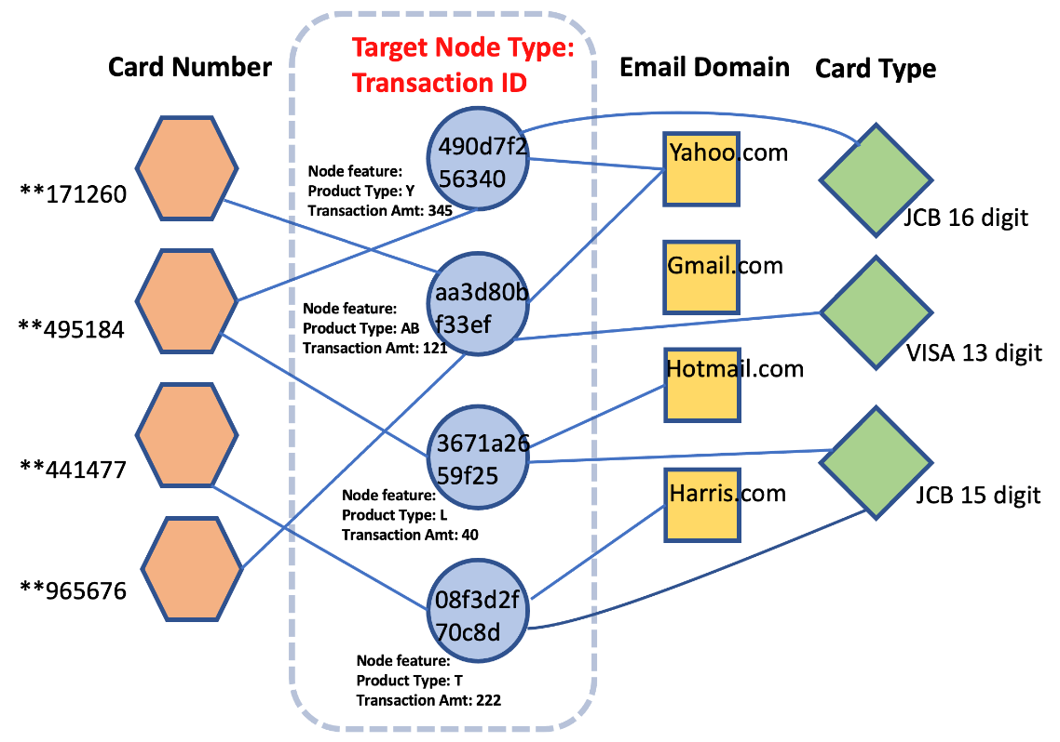
Danske Bank replaced its traditional rule-based system with a Machine Learning-based fraud detection platform.
Technologies Used
1. Machine Learning Algorithms
The bank used supervised machine learning models trained on historical transaction data. These models learned to distinguish between:
- Legitimate transactions
- Fraudulent transactions
Common algorithms used in fraud detection include:
- Logistic Regression
- Decision Trees
- Neural Networks
- Random Forest
2. Big Data Analytics
The AI system analyzes millions of transactions and considers factors such as:
- Transaction amount
- Location
- Frequency
- Customer spending patterns
- Device information
3. Real-Time Detection System
The system evaluates transactions instantly and assigns a fraud probability score. If the score exceeds a threshold, the transaction is flagged or blocked.
How It Works (Step-by-Step)
- Customer makes a transaction
- Transaction data is sent to AI system
- AI compares it with normal behavior patterns
- AI assigns fraud risk score
- Bank takes action:
- Approve transaction
- Flag transaction
- Block transaction
Benefits
Danske Bank achieved significant improvements after implementing AI.
1. Increased Fraud Detection Rate
They actually caught 50% more real fraud than they did with the old system. This means more fraudulent transactions were successfully stopped.
2. Reduction in False Positives
Fewer customers complaints, they cut down "false positives" by 60% right out of the gate. That means way fewer people having their cards declined while just trying to buy groceries.
3. Cost Savings
Fraud prevention saved the bank millions of dollars annually by:
- Preventing financial losses
- Reducing manual investigation work
- Increasing operational efficiency
4. Faster Detection
AI works in real-time, allowing fraud to be stopped immediately rather than after damage occurs.
Challenges
Despite its success, the bank faced several challenges.
1. Data Quality and Availability
AI requires large amounts of high-quality data. Some challenges included are incomplete data, data cleaning requirements and integrating multiple databases.
2. Implementation Cost
AI systems are expensive to implement due to infrastructure costs, software development and hiring AI specialists.
3. Ethical and Privacy Concerns
Banks must protect customer data like data privacy regulations, responsible AI use and most of all transparency.
4. Model Maintenance
Fraud patterns constantly change. The AI system requires continuous training, monitoring and constant debugging and updates.
Conclusion
Overall, AI helped Danske Bank significantly upgrade its fraud detection. The system works faster and smarter, catching fraud more accurately and reducing annoying false alarms. While setup and maintenance can be challenging, the benefits especially for customers make using AI worthwhile.
As fraud continues to evolve, more banks are likely to adopt machine learning because it can adapt better than traditional systems.
Chart Impact of AI:
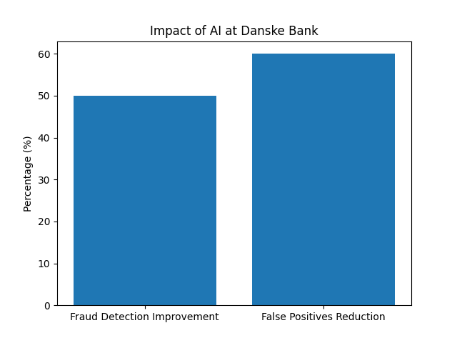

References:
Danske Bank. (2019). Better fraud detection with AI. Retrieved from
https://danskebank.com
AI Business. (2024). Danske Bank fights fraud with machine learning. Retrieved from
https://ai.business/case-studies/enhancing-fraud-detection-through-ai-a-danske-bank-journey/

Constellation Reserch. (2018). Danske Bank Fights Fraud with Machine Learning and AI. https://www.constellationr.com/research/danske-bank-fights-fraud-machine-learning-and-ai
Teradata. Danske Bank Fights Fraud with Deep Learning and AI. https://assets.teradata.com/resourceCenter/downloads/CaseStudies/CaseStudy_EB9821_Danske_Bank_Saves_Millions_Fighting_Fraud_With_Deep_Learning_and_AI.pdf

